Name: _________________

Date: __________________

**Warm Up 1.3 SHOW YOUR WORK!!!**

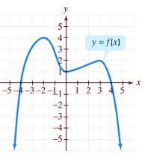Solve the following problems by hand, use a graphing calculator to check:

1.

1. The domain of f: _____________________
2. The range of f: ______________________
3. The x-intercept(s): ___________________
4. The y-intercept: ____________________
5. Interval(s) on which f is increasing: ___________________



1. Interval(s) on which f is decreasing: __________________
2. The x value(s) at which f has a relative maximum or minimum: ____________________
3. The relative maxima of f: _______________________
4. The relative minimum of f: _____________________
5.  _____________________
6. The value(s) of x for which f(x) = 0: ________________________

2. Simplify